### **BAMBU LABS X1:**

### **Step 1: Download Bambu Studio**

1. Open your web browser and go to the **Bambu Lab Studio** official website: [Bambu Lab Studio](https://bambulab.com/en/download/studio).

### **Step 2: Launch Bambu Studio**

1. Once the installation is complete, click the **Finish** button.
2. Find the **Bambu Studio** icon on your desktop or in your applications list.
3. Double-click to open **Bambu Studio**.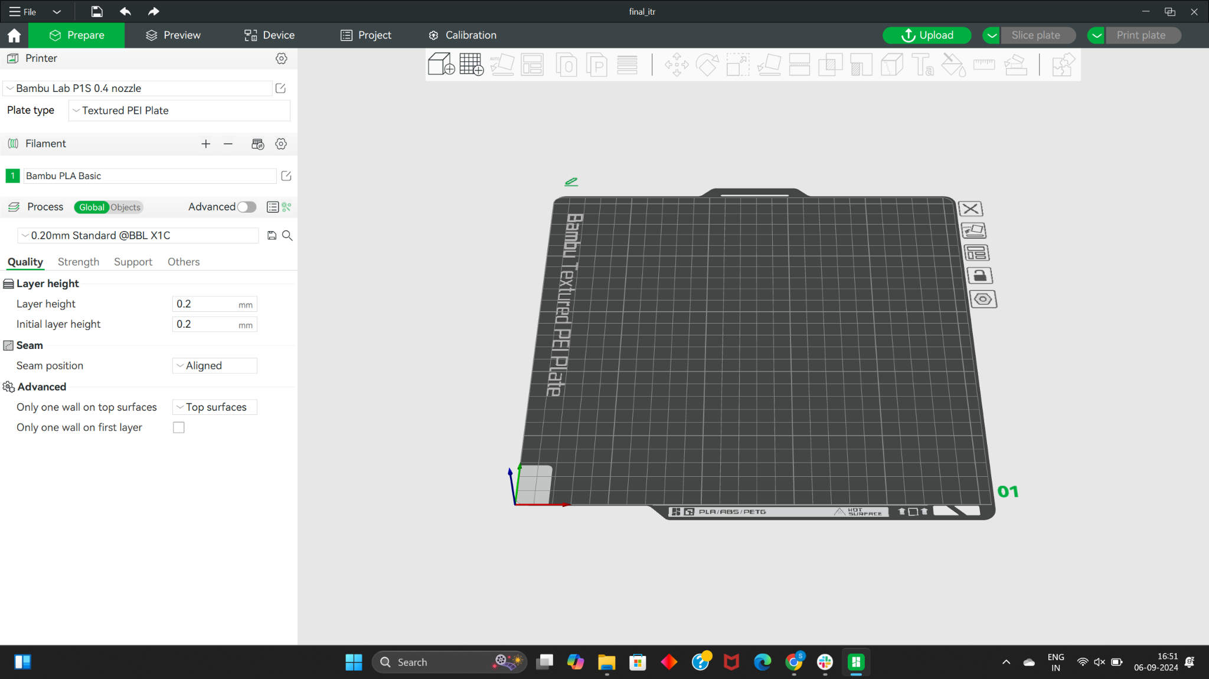

### **Step 3: Connect Your 3D Printer**

1. In Bambu Studio, go to the **Device** icon in the top menu bar.
2. Add your **Bambu Labs X1 3D Printer** (NAME: mrsd-4) by clicking **Add Printer**.
   * If you’re using Wi-Fi, ensure the printer is connected to the same network as your computer. – Use (cmu-device wifi)
   * Enter the printer’s IP address or search for it automatically.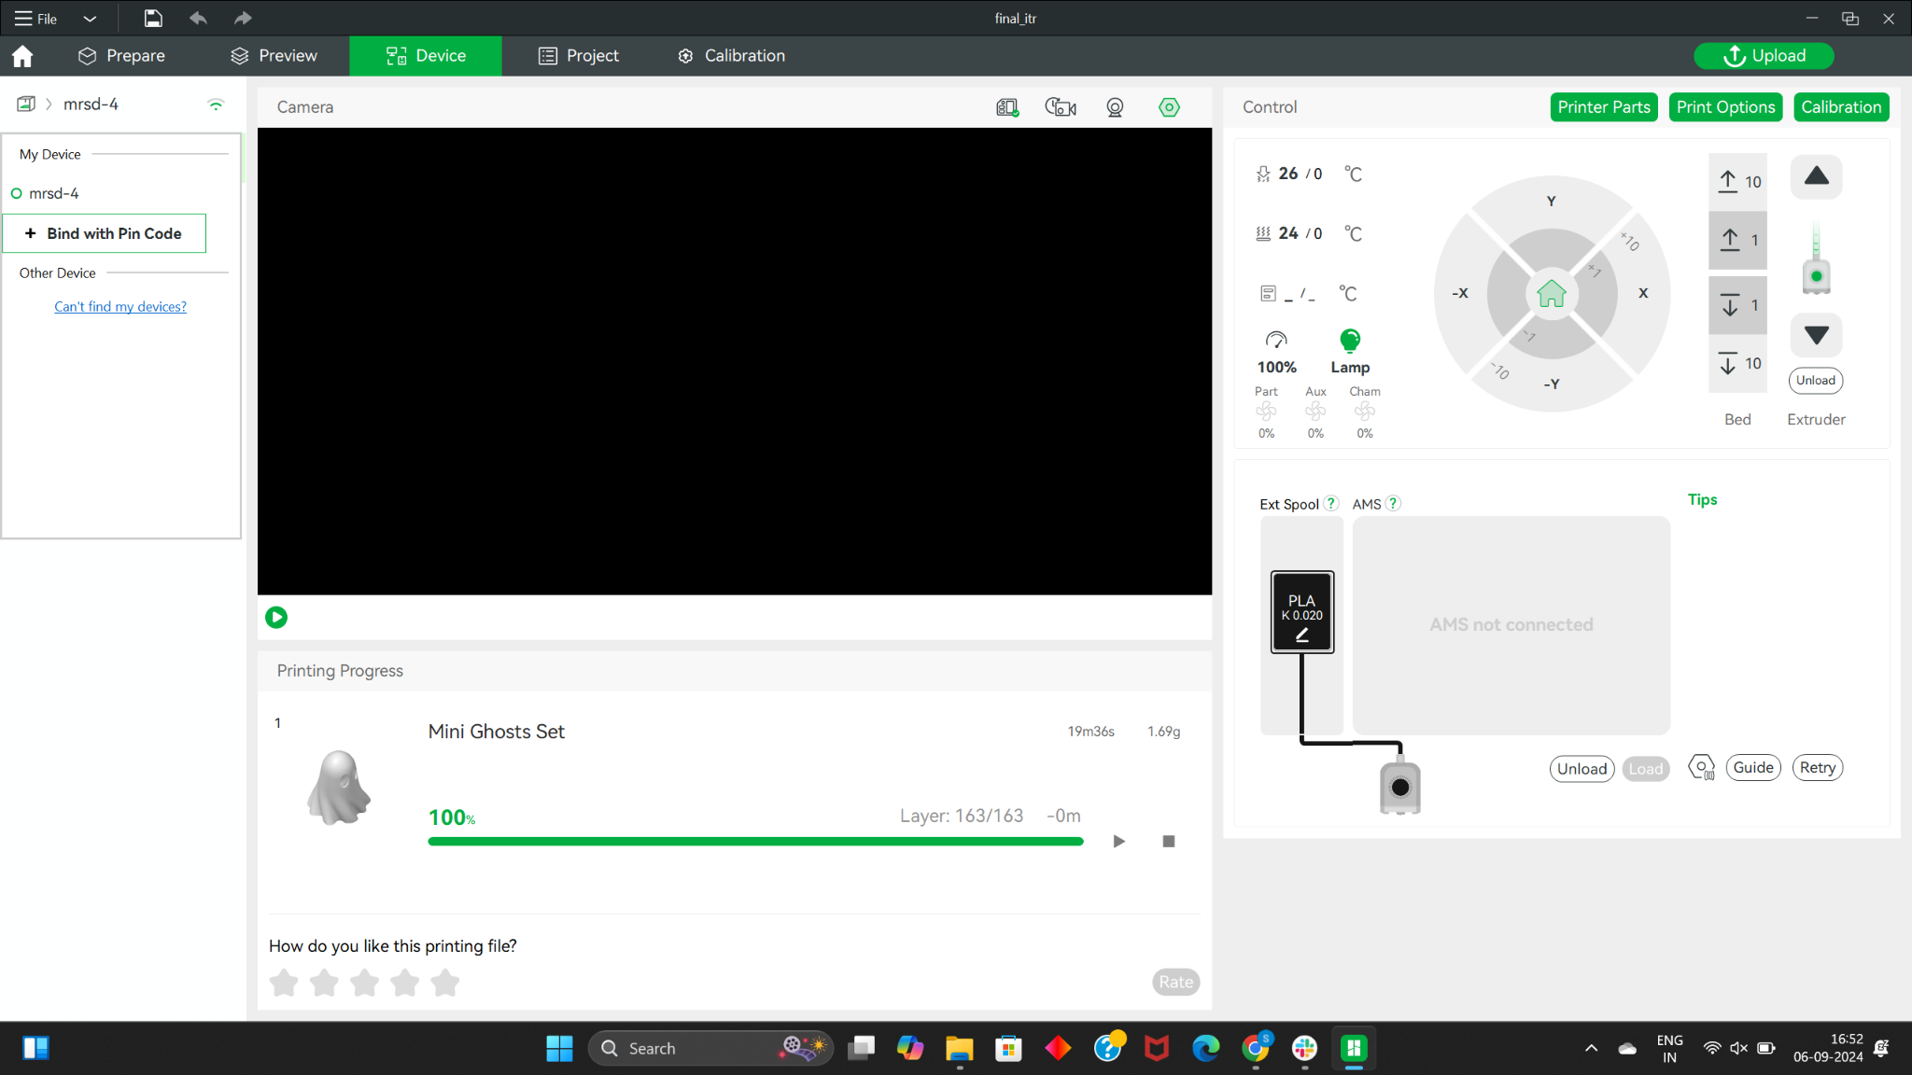

### **Step 4: Configure Print Settings**

1. After connecting the printer, choose the material you're going to print with.
   * Select **PLA**, **ABS**, **PETG**, or any other material compatible with the printer.
   * Currently the printer is using PLA material.
2. Adjust your print settings for layer height, infill, and support options as needed.

### **Step 5: Slice the 3D Model**

1. Open your 3D model file (usually in **.stl** or **.obj** format) by clicking **File** → **Open** or drag and drop it into the Bambu Studio window. Your cad file should be on the **Prepare** page.

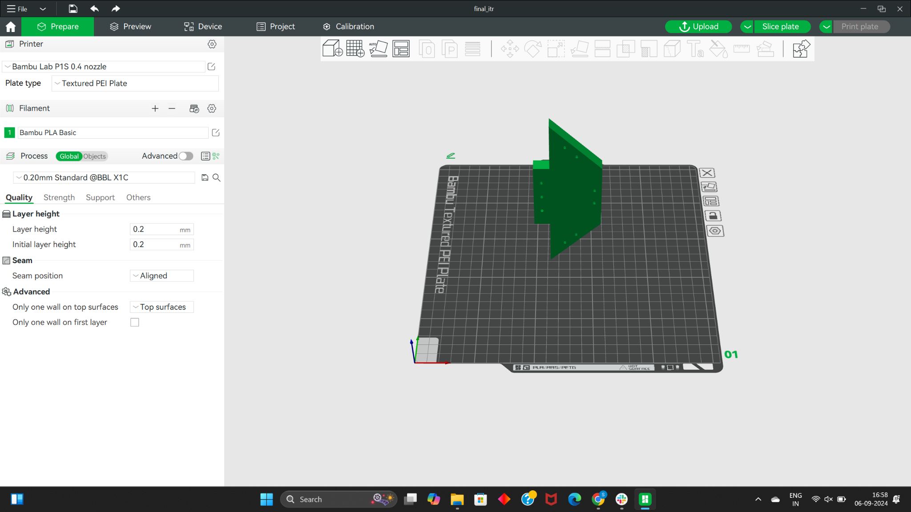

1. Check the orientation and scale of your model to ensure it’s ready for printing. Use the Auto-orient button on the top to orient it appropriately for 3D printing.

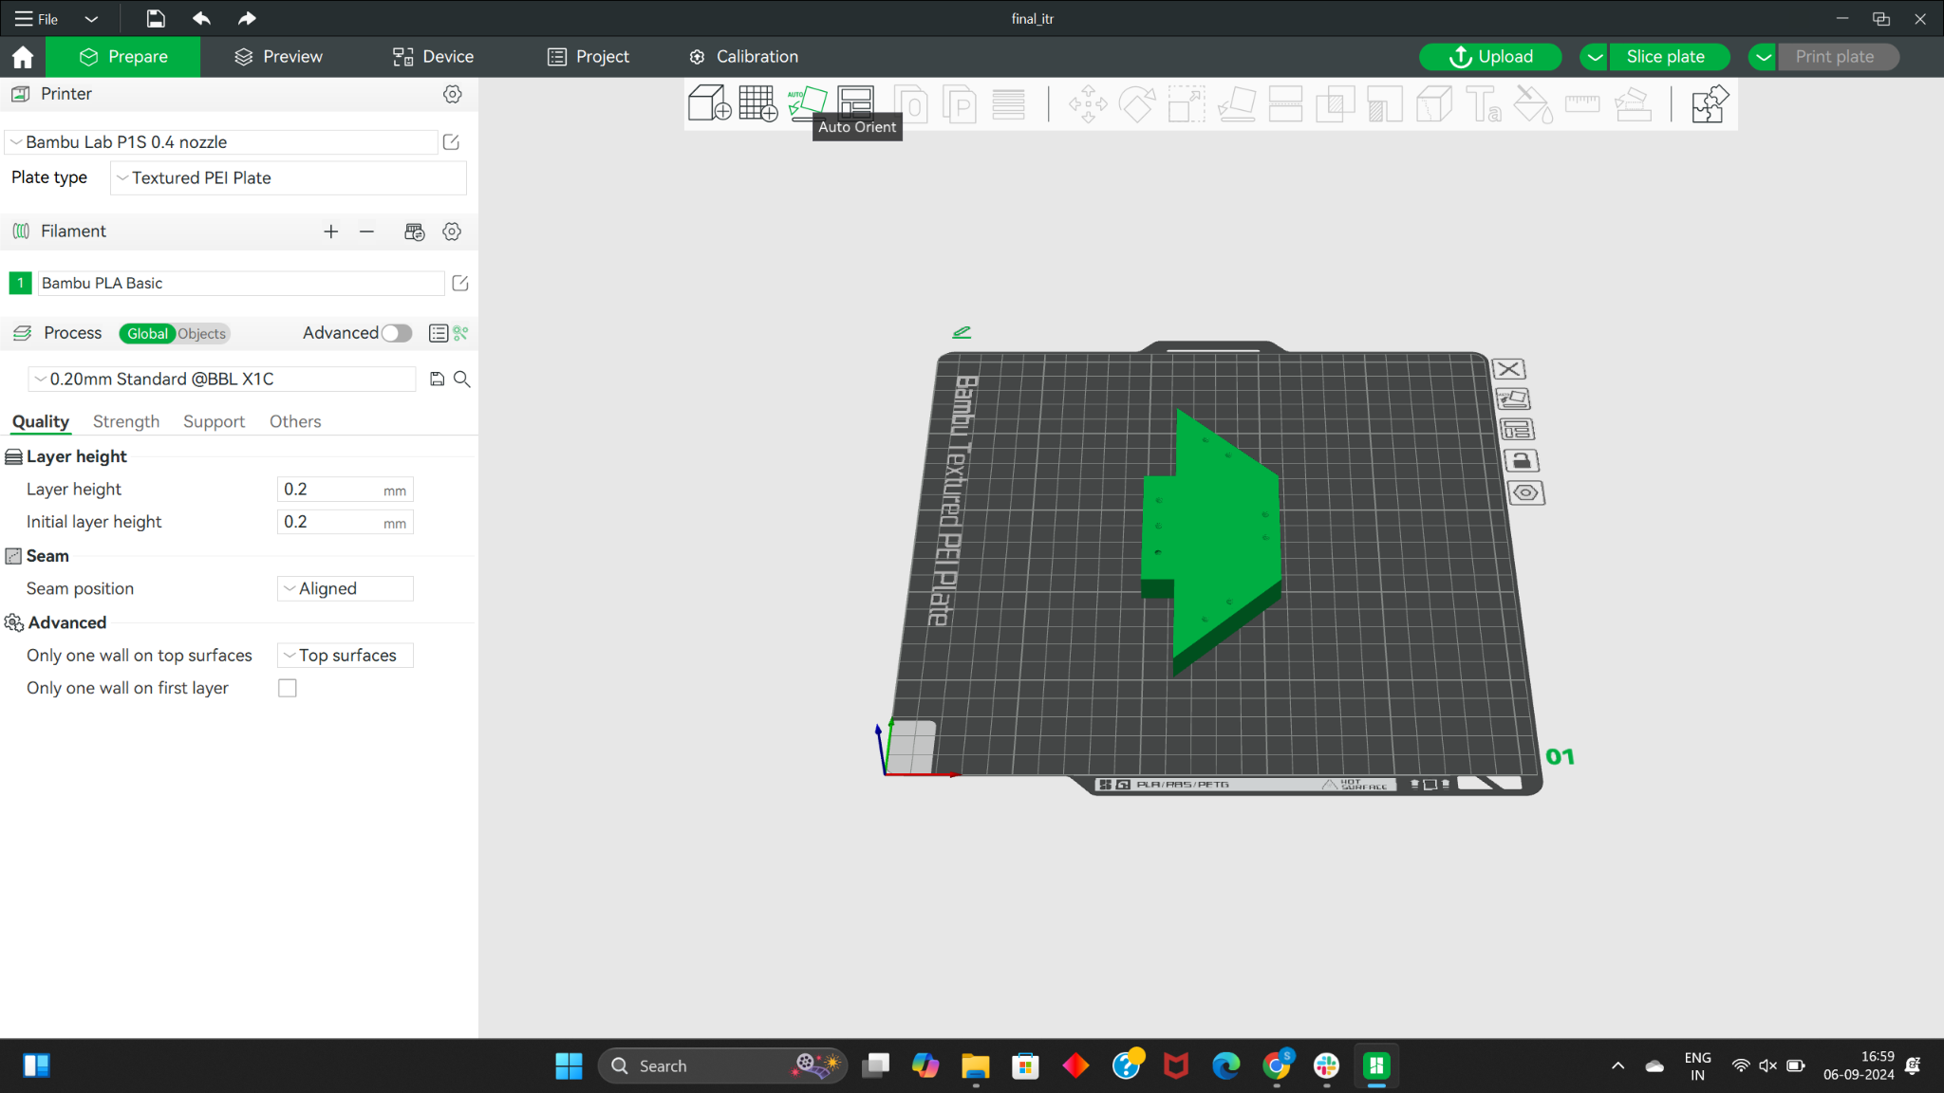

1. Click the **Slice plate** button to prepare the file for printing.
2. Import multiple components to be print at once by clicking **File** → **Import**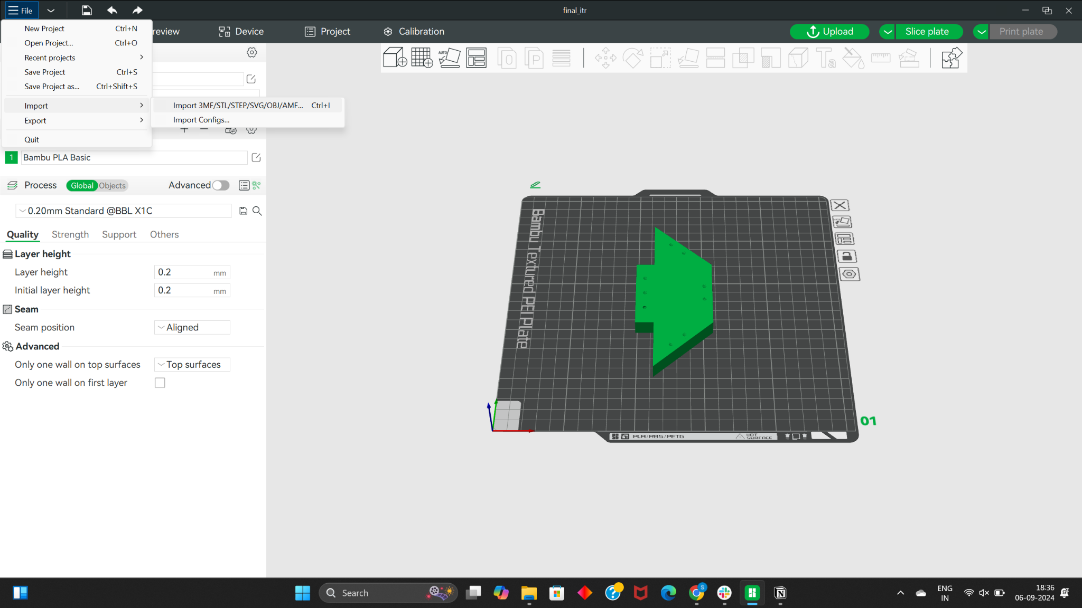

### **Step 6: Start Printing**

1. Once your model is sliced, click the **Print Plate** button.
2. You can choose to print via USB or over Wi-Fi if the printer and your computer are on the same network.
3. Monitor your print progress in **Bambu Studio**, and ensure everything is set up correctly.

**DEBUG:**

If you are unable to connect to the 3D printer directly using your laptop:

Step 1: Install Bambu labs app on your mobile device.

Step 2: Create an account and login to the app.

Step 3: Scan the barcode given in the bottom right corner of the printer.

Step 4: Your user account will now be connected to the 3D printer

Step 5: Login using the same account on your desktop and print the component.

Step 6: Please logout your user account from the printer after use.

### **PRUSA 3D printer:**

### **Step 1: Install a Slicer Software**

Students can choose and install any slicer software like **PrusaSlicer**, **Ultimaker Cura**, or **Simplify3D**. Here’s a quick installation guide for **PrusaSlicer**:

#### **Installing PrusaSlicer**

1. Download **PrusaSlicer** from the official Prusa website: [PrusaSlicer Download](https://www.prusa3d.com/page/prusaslicer_424/).

### **Step 2: Prepare the 3D Model**

1. Open your slicer software and load your **3D model** file (in **.stl** or **.obj** format).
2. Configure your slicer settings based on the material you’re using:
   * **PLA**, **PETG**, etc.
   * Choose the appropriate layer height, infill, supports, and print speed.
3. Make sure the model is properly scaled and positioned for printing.

### **Step 3: Slice the Model**

1. Once your 3D model is ready, click the **Slice** button in your slicer software.
   * This will generate a **.gcode** file which is the machine-readable format for 3D printers.
2. Save the **.gcode** file to your computer.

### **Step 4: Prepare the USB Drive**

1. Take the **USB drive** provided for the **Prusa 3D Printer**.
2. Plug the USB into your computer.
3. Open the USB drive and look for a folder named **MRSD_2026**.
   * If the folder doesn’t exist, create a new folder with that name.
4. Copy your sliced **.gcode** file into the **MRSD_2026** folder on the USB drive.

### **Step 5: Insert USB into the Prusa 3D Printer**

1. Safely eject the USB from your computer and insert it into the **Prusa 3D Printer**'s USB slot.

### **Step 6: Select Your File on the Printer**

1. Turn the **Prusa 3D Printer** on.
2. Use the knob on the printer’s front panel to navigate through the menu.
3. Navigate to **Print from SD/USB** or **Select File**
4. Find the **MRSD_2026** folder and locate your **.gcode** file.
5. Select your file and press the knob to start the print.

### **Step 7: Start the Print**

1. Once the print starts, monitor the initial layer to ensure proper adhesion.
2. Stay nearby for the first few minutes to ensure everything is working correctly.